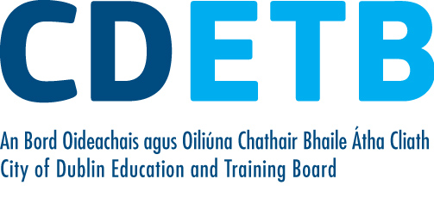
Prompt Payments by Public Sector Bodies

Reporting Template pursuant to Government Decision S29296 of 2 and 8 March 2011 and 28 March 2017 by:

The Health Service Executive, the Local Authorities, State Agencies and all other Public Sector Bodies, (excluding Commercial Semi State bodies)

Parent Government Department: Department of Education and Skills
Public Sector Body: City of Dublin ETB
Quarterly Period Covered: 01 October 21-December 21

Details | Number | Value  (€) | Percentage (%) of  total number of payments made
Total payments made in Quarter | 9,898 | 14,022,437 | 100%
Payments made within 15 days | 4,147 | 9,615,038 | 41.90
Payments made within  16 days to 30 days | 4,380 | 3,833,247 | 44.25
Payments made in excess of  30 days that were subject to LPI and compensation costs | 62 | 31,176 | 0.63
Payments made in excess of  30 days that were not subject to LPI and compensation costs | 1,309 | 542,976 | 13.22
Amount of late payment interest (LPI) paid in Quarter | N/A | 101 | N/A
Amount of compensation costs paid in Quarter | N/A | 2,720 | N/A

Signed: Finance Dept

Date: 24/01/22

Please return completed template to: PromptPaymentReturns@education.gov.ie

