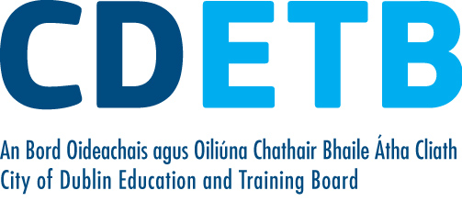

Prompt Payments by Public Sector Bodies

Reporting Template pursuant to Government Decision S29296 of 2 and 8 March 2011 and 28 March 2017 by:

The Health Service Executive, the Local Authorities, State Agencies and all other Public Sector Bodies, (excluding Commercial Semi State bodies)

Parent Government Department: Department of Education and Skills
Public Sector Body: City of Dublin ETB
Quarterly Period Covered: Jan 21-Mar 21
Details | Number | Value  (€) | Percentage (%) of  total number of payments made
Total payments made in Quarter | 5,672 | 6,729,254 | 100%
Payments made within 15 days | 2,521 | 3,466,652 | 45.45%
Payments made within  16 days to 30 days | 2,580 | 2,636,634 | 45.49%
Payments made in excess of  30 days that were subject to LPI and compensation costs | 31 | 12,075 | .55%
Payments made in excess of  30 days that were not subject to LPI and compensation costs | 540 | 613,892 | 9.52%
Amount of late payment interest (LPI) paid in Quarter | N/A | 164 | N/A
Amount of compensation costs paid in Quarter | N/A | 2,300 | N/A

Signed: Finance Dept

Date: 26/04/21
Please return completed template to:
Parent Department: Business, Enterprise and Innovation
Address: 23 Kildare Street, Dublin 2
Phone No: 01-6312249
E-mail: promptpayment@dbei.gov.ie

