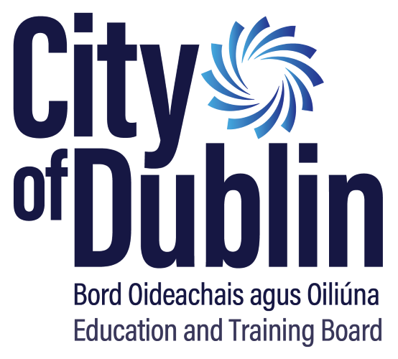

Reach Fund 2026 Guidelines

Closing Date for receipt of applications is:
Thursday 29th January 2026

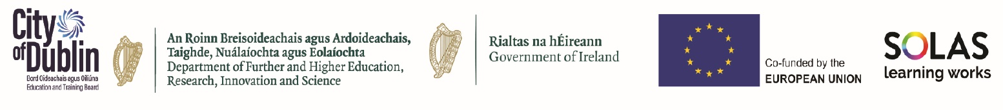
Introduction
City of Dublin ETB is delighted to open the Reach Fund 2026 for applications. The closing date for applications is Thursday 29th January 2026. Please note that applications received after the deadline will not be considered.
The aim of the Reach Fund 2026 is to provide support to the most educationally disadvantaged learners in accessing and participating in community education.

These guidelines contain:
Section 1: Overview of Reach Fund 2026 ……………………………page 3
Section 2: Applying for Reach Fund 2026 …………………………….page 4
Section 3: Funding Terms and Conditions …………………………… page 7
Section 4: Support with your Application ……………………………. page 9
Appendices ……………………………………………………………………page 10

Section 1: Overview of the Reach Fund 2026
The aim of Reach funding is to provide support to the most educationally disadvantaged learners in accessing and participating in community education initiatives.
As defined in the recently published ‘Community Education Framework – Transforming Learning’: “Community Education is both formal and non-formal learning led by communities for communities to support personal, social, educational, environmental, economic and community development”.
The Reach Fund 2026 is not intended to support learners attending PLC courses, Youthreach programmes, etc., at National Framework of Qualifications levels 4 or higher.

The Principles of Reach funding are:
To assist community education providers to widen and increase their capacity to deliver, support and encourage participation of educationally disadvantaged learners, particularly those on accredited programmes at National Framework of Qualifications levels 1 to 3.
To support community education principles by including both formal and informal learning, addressing learners’ personal development, building skills while offering educational options through simplified pathways, and further opportunities to progress to other areas of FET and beyond.
To tackle inequalities and support access to community education.
To support community education projects where clear evidence of viability exists, which ensures that the benefits of the investment are maintained beyond the funding period, enhancing the long-term impact of the funding.
To address topics such as climate justice education, education for sustainable development and building climate literacy.
To widen and increase the participation of educationally disadvantaged
learners, particularly those at National Framework of Qualifications (NFQ) levels
1 to 3.

The Reach Fund 2026 is not intended to support learners attending PLC courses, Youthreach programmes, etc., at National Framework of Qualifications levels 4 or higher
Projects should not have any adverse impact on existing services or provision funded through ETBs.

Section 2: Applying for Reach Fund 2026

2.1 Application
To apply for the City of Dublin ETB Reach Fund 2026 submit all of the following completed documents by Thursday 29th January 2026

- The Online Application Form here: Reach Fund 2026 Application Form - External Applicants – Fill out form

The following documents must be submitted to info@aes.cdetb.ie

- Breakdown of Costings
- Copies of quotations where necessary
- A signed copy of your 2024 audited accounts.

Please note that 2025 signed audited accounts must be forwarded to City of Dublin ETB by 30th June 2026.

2.2 Eligible and Ineligible costs:
Quotations for all orders over €1,000 excluding VAT must be included at application stage.
All procurement guidelines must be abided to (see Appendix 1).

Staff costs:
Reach funding may be used for staff costs which are:
- for a specific purpose or fixed term
and
- relate directly to the Reach project.
Commitments/contracts must not extend beyond the end of 2026. Applications must clearly show that they are fully compliant with Revenue and all employment legislation requirements.
Ineligible costs
The following expenditure is not eligible for Reach Fund 2026:
- Cost of a recurring nature
- Capital items (the cost of any item exceeding €1,000 excluding VAT)
- Vouchers for Learners.
- Programme Validation Costs

2.3 Funding Categories
You must apply under one or more of the four funding categories. Organisations are encouraged to apply under one category for a project and not spread costs across multiple categories unless there is a strong justification for doing so.

- Participation of Priority Groups
Projects focused on widening and increasing participation of priority groups in learning that offers accreditation at NFQ level 1 to 3, or on non-accredited programmes that provide clear pathways to accredited provision at NFQ levels 1 to 3.
The key priority groups for Reach funding, in line with those identified in the Community
Education Framework, are:
- Learners 16 - 25 years of age
- Long-term unemployed
- People with disabilities
- Migrants and refugees
Other priority groups:
- Early school leavers
- Members of the Traveller and Roma communities
- Women wishing to return to the labour market
- Lone parents
- People who are educationally, economically or socially disadvantaged
- People impacted by mental health issues or addiction
- Women’s groups and men’s groups
- People impacted by homelessness
- Carers
- LGBTQIA
- Older people

- Learner Support
Projects that will support learners to engage/participate in community based educational programmes, mentoring projects, transport costs for learners, urgent educational response.

- Climate & Sustainability
Projects that address topics such as climate justice education, education for sustainable development or building climate literacy.

- Outreach / Pre-Development
Projects engaged in education outreach and pre-development work to support the most marginalised and disadvantaged groups.

Section 3: Funding Terms and Conditions

3.1 Funding Terms and Conditions
If successful, the Reach Fund 2026 grant must:
1. Be used for the specific purpose intended, as per application and approval.
2. Be fully spent by year end 2026. Unspent funding cannot be carried forward to 2027 and must be returned.
3. Not be used for:
- Cost of a recurring nature
- Capital items (the cost of any item exceeding €1,000 excluding VAT)
- Vouchers for Learners
- Programme Validation Costs

Applicant organisations must:
4. Be tax compliant and provide a Tax Clearance Access Number (TCAN) along with the Tax Reference Number and Charity Number (CHY) (if applicable) on the application form.
5. Comply with purchasing/procurement rules - see Appendix 1
6. Provide copies of quotations for orders over €1,000 excluding VAT – see Appendix 1
7. Submit a copy of your 2024 signed audited accounts with your application.
8. Submit a copy of your 2025 signed audited accounts by 30th June 2026.
9. Return any unspent monies as of the 31st December 2026 to City of Dublin ETB promptly.
10. Submit a signed Income and Expenditure spreadsheet to include invoices and receipts to City of Dublin ETB at info@aes.cdetb.ie before Friday 15th January 2027. Where the project includes staff pay, copies of contracts of employment and evidence of Revenue and Employment compliance will be required.

Other Terms and Conditions
- If introducing an ICT Equipment Loan Scheme, you are required to have a tracking policy and assets register in place for audit purposes. Please see Appendix 2 for a sample template.

- If you are purchasing Leap Cards, you need a register of recipients for audit purposes. Please email Appendix 3 for a sample template.

3.2 Capital Threshold
Capital items are not allowable under the Reach Fund. The cost of any one item cannot exceed €1,000 excl. VAT.
Accounting standards state that all costs attributable to bringing an asset into use determine the value of the asset.
For example: If you purchase an item at a cost of €900 and the accessories plus installation are an additional €150, this item is considered capital. The total cost of bringing this item into use is €1,050 before VAT. It is therefore not eligible under the Reach Fund.

3.3 Services
Services do not come under capital threshold. All centres, if applying for a service, must abide by the purchasing/procurement guidelines.

Section 4: Support with your Application

Live Online Information Sessions
Applicants are strongly encouraged to attend a live online information session for support on the Reach Fund Guidelines. The following zoom information session dates are available:
1. Monday 12th January at 10:00: https://us06web.zoom.us/j/81232357333

2. Thursday 14th January at 14:00: https://us06web.zoom.us/j/89089360625

Appendix 1 – Purchasing Rules & Regulations

City of Dublin ETB Procurement Guidance
The below thresholds are effective from 1st January 2024
Goods and Services

Threshold (exc of VAT) | Requirements
< €1,000 | One verbal or written quote
≥ €1,000 - < €5,000 | One written quote
≥ €5,000 - < €50,000 | Seek three written quotes
≥ €50,000 - < €221,000 | Tender – National
≥ €221,000 | Tender – OJEU

Appendix 2 – Example ICT Loan Agreement Policy
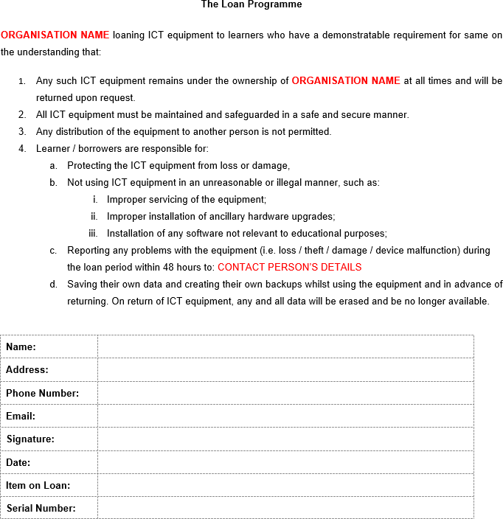

Appendix 3 – Leap Card Record of Distribution Example

LEAP CARD RECORD OF DISTRIBUTION
Leap Card  Serial Number | Person Allocated To | Signature | Rationale for Allocation | Date  Allocated

