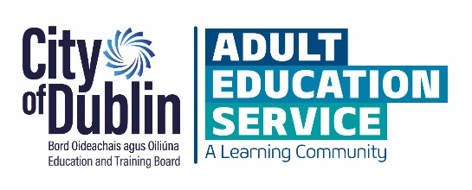
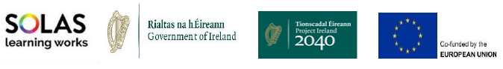
Applications will only be accepted if:
- All questions are answered
- Received by closing date
- All requested documentation/Information is included
Submit completed application to info@aes.cdetb.ie
By: 8th March 2024 @ 5pm
Reach Fund 2024
Application Form

APPLICATION FORM
*All sections of this form must be completed to be considered for City of Dublin ETB’s Reach Fund 2024.
*All applicants are invited to attend a live online information session.

Section 1: Applicant Information
Name of your Community Group/Organisation:
Title of Proposed Project:
Organisation Address:
City of Dublin ETB Internal Organisation |  | OR |  | Community Based Organisation

1.2 Contact Details (please provide contact details for 2 people in your organisation):
Contact person 1st name:
Position:
Email Address:
Phone Number:
Contact person 2nd name:
Position:
Email Address:
Phone Number:

Section 2: Funding
 | Yes | No
Have you applied for Reach funding from any other source this year (2024)?
Have your received Reach or MAED Funding in previous years from any other source?
If you have applied for or received MAED or Reach Funding from another source, please provide details below:

Community Based Organisations ONLY: Please complete this section
2.2 Financial Details
Tax Clearance (please attach details of your current tax clearance status with this application)
Tax registration number:
Tax clearance access code:
CHY number (if applicable): |  | CHY
Bank Details (Bank Account you want the reach funding to be paid into)
Name of bank:
Address of bank
IBAN: |  | BIC:

2.3 Project Costs
A completed Breakdown of Costings spreadsheet must be completed and returned with this application.
Breakdown of Project Costs per Category:
Learner Assistance Support | €
Green Projects | €
Increasing Participation of Priority Target groups | €
Equality Awareness Events / Awareness Campaigns | €
Adult Literacy for Life (ALL Strategy) Target Groups | €
Pre-development Work for Community Groups Supporting Marginalised Groups | €
Support for Refugee Groups | €
Total Grant Request amount: | €

Section 3: Project Checklist

Tick which of the below priority groups your project will work with. Please tick all that apply.
Priority Target Groups
- Long-term unemployed
- Young people 16+
- People with Disabilities
- Members of the Traveller and/or Roma Communities
- Migrants and Refugees
- Women wishing to return to the labour market
- One-parent households / Lone parents
- Older Adults (55+)
- Low paid workers
- Carers
- People with language needs
- Incarcerated persons and ex-offenders
- Persons recovering from addiction
Provide a brief description of the beneficiaries/learners of your project? (100 words max)
If you use the City of Dublin PLSS data base, will the project outcomes be linked to beneficiaries on PLSS? | Yes |  | No
Is your community group located within an unemployment blackspot/area of disadvantage within the City of Dublin ETBs Region?  If yes, please list which area/s below: | Yes |  | No
Does your project duplicate the work of any other community education or community development organisations within your catchment area? | Yes |  | No

Section 4: Proposed Reach Project Details
Summarise the Proposed Reach Project (25 words max)
Describe the Proposed Reach Project: (350 words max)
Outline the positive educational outcomes this proposed project will achieve for learners. List how you will measure / capture these outcomes. (max 150 words)
Estimated number of learners who will benefit from your proposed Reach project before the end of the year 2024 (only enter a number in the answer to this question)

Section 5: Checklist for application:
I have read and agree to the terms and conditions of the City of Dublin ETB Reach Fund Grant 2024
I have completed all sections of this application.
I have included the “Breakdown of Costings per Category” spreadsheet
I have provided quotations where required
I have provided a copy of my 2022 signed audited accounts
Signed Declaration – confirmation that the Application Form has been completed in full and that all information provided is accurate and complies with the Reach Fund grant criteria and purchasing rules.
A scanned signature will be accepted
Note: If all necessary documentation is not included, this will may result in your application not being eligible.

Section 6: Submission Details
I declare on behalf of (insert organisation name here)
That I have the appropriate authority to make this submission for funding. This application for funding is fully completed and the information provided is a full and accurate account of how the funding (if allocated) will be used in 2024.
I confirm that there is no duplication of public funding |  |  | Yes | No
I confirm that the conditions of the funding will be complied with if applications are successful |  |  | Yes | No
Signature (not typed) |  | Print Name
Position in Organisation |  | Date

Signed Applications & Breakdown of Costings Spreadsheet to be returned by email to: info@aes.cdetb.ie
Closing date for receipt of applications:
8th March 2024 @ 5pm

